Gail Smith
Professor Corbally
English C1000
19 July 2025
Upcycling Stuff Essay
I look inside my junk drawer to find an object from my childhood to look back and remember on, it is hard to find anything because of the extreme amount of disorganization. My junk drawer is a chaotic mess of items without any organization. I do not know whether to do away with certain items because they either hold value to me or were gifted to me by someone I love. Looking inside my junk drawer I first see a toy Hot Wheels car that is yellow with red flames on the sides of the car and the number “68” on it, also, there is a pamphlet from my 2025 youth summer camp that has the words “JESUS IS” on it with gray splatters of color all over it, a silicone USA bracelet that has a red and blue side with the red side having white stripes and the blue side having white stars, there are green and slippery money bills that are fake that I acquired from Pretend City, a fake, bright, neon green plastic snake that has notches in it so that it can bend, and finally, a blue phone holder with two hands that are connected to each other giving a thumbs up. If I want to find an item from my childhood in my junk drawer, I should consider upcycling or repurposing some of the items in it to make it easier to find objects inside this drawer. Upcycling some of my items in my junk drawer might solve my solution quite well.
Upcycling is the process of taking old or unused items and making them have a purpose again. One article states that “upcycling involves creatively elevating the value of waste materials to create new materials or products with improved quality. This process extends their lifespan and reduces waste” (“Upcycling Defined: A Creative Approach to Sustainable Living”). Upcycling has been around for a long time. Even though it is a trend now, it was used for many purposes in the past. During the time of Queen Victoria, “Princess Alexandra of Denmark, the queen’s daughter-in-law, asked English couturier Elise Kreutzer to continuously repurpose her own gowns – including her wedding dress” (“The History of Upcycling”). That was well over 100 years ago. This same practice of extending the life of clothing and repurposing items was also popular in the UK during World War II when there was cloth rationing. “Sarting June 1, 1941. With supplies diverted to produce war uniforms, the ‘Make Do and Mend’ campaign encouraged citizens to extend lifespan through repairs and creative reuse of household textiles like curtains and tablecloths” (She). People had to get creative to extend very limited resources while helping the war effort. They gave old items a new life.
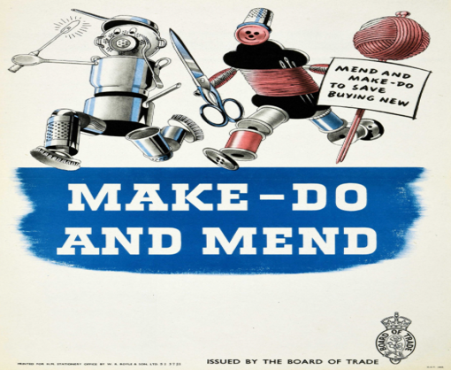
Another such instance where upcycling was practiced in the past was during the 1950’s and 1960’s. Upcycling was very popular with the junk art movement during these eras:
Inspired by Duchamp’s found art movement in the early 1900s, in the 1950’s we saw the emergence of the junk art movement. The name junk art was coined by British art critic Lawrence Alloway, it was to describe art made from scrap metal, broken machinery, timber, or other materials that were considered to be ‘waste. Pioneers of the junk art movement are artists such as Robert Rauschenberg, Christo Javacheff, Ettienne Martinand with Antoni Tapies, artists from Spain and Italy also involved in the movement and technique. (“The History of Upcycling”)
Similarly, there are artists today who make sculptures out of things like old tires, bottles (and bottle caps), and just random junk. The materials can be creatively arranged in shadow boxes and on walls to turn trash into treasure.
There are several reasons why upcycling is trending nowadays. One reason it is popular is because it can benefit our environment. In fashion, specifically, upcycling is enormously popular because it can lower the carbon footprint drastically. “As awareness surrounding the fashion industry and its impact on our planet becomes more apparent, and the demand for sustainable alternatives continues to grow, people are looking for viable alternatives. As fashion is culture, and culture drives change, Upcycling is in the perfect position to lead the change we so evidently need in the fashion industry” (“The Rise Of Upcycling; A New Era For Fashion”). Upcycling then is very popular in part because by partaking in it, people can help to better the environment and the world we live in. “Upcycling is a creative solution to the climate crisis; it enables brands and designers to continue to produce without adding to the fashion industry’s waste problem. Upcycling makes use of existing pieces of clothing and material, uses minimal additional resources, and ultimately reduces the number of unwanted items that are thrown into the landfill” (“The Rise Of Upcycling; A New Era For Fashion”). The ecological footprint is a concerning topic among many people today so if upcycling clothing or other such items can help lower the footprint, people want to join in this so that they can help the environment and feel like they have done their part. There is much waste involving clothes, “as it stands, the fashion industry is not sustainable; each year, 1.5 trillion tonnes of water is used to make clothing; and out of the 100 Billion pieces of clothing that is produced each year, only 1% are recycled into new clothing” (“The Rise Of Upcycling; A New Era For Fashion”). This is one reason why upcycling is admired in today’s world because by upcycling just clothing alone, it can save much waste and help the environment.
The idea of changing an old or unused item into something that is useful again is not only popular today because it can lessen the ecological footprint, but also because it allows people to express themselves and be creative. Being creative is an important aspect of upcycling. “The role of creativity in upcycling is fundamental. It’s the spark that ignites the entire process. Without creative thinking, upcycling wouldn’t exist” (Zellinger). The creative aspect of upcycling is what many people find enjoyable, and it inspires them to repurpose old objects. Upcycling different items and making them into a new and quite pleasing thing brings fulfillment to people. People are satisfied when they can upcycle an object to either make it look prettier or have a better use. For example:
There is an argument that upcycling can promote happiness, and is tied to our need for self-expression. By creating unique items through upcycling, people can express themselves artistically, leading to an increased sense of personal fulfillment. Additionally, knowing that one is contributing to a more sustainable world can provide a sense of purpose and well-being. (Zellinger)
Upcycling, as stated in the article, brings much fulfillment to people since they know that they not only made an item that may look pleasant, but that it is their own and they can show others. When people make or upcycle an object themselves, they feel accomplished especially if it turns out better than they thought it would have. This creative aspect of upcycling as well as making an item and repurposing it to become better is partly what keeps upcycling popular today. People love to find fulfillment in hobbies and upcycling does that by allowing people to be creative and be proud of what they made. This is especially true if that object would have been thrown in the trash if it were not for them upcycling it.
My junk drawer is still a mess, but I now know that I can upcycle certain items in it to make it more organized. Upcycling my items in my junk drawer would be a better fit than throwing them in the trash. Not throwing my items away helps with the waste problem, but it also allows me to be able to keep the objects that still hold value to me while giving them a new purpose. One idea I had to organize my junk drawer is to make a memory box with some of the items that are in my drawer that are unused.

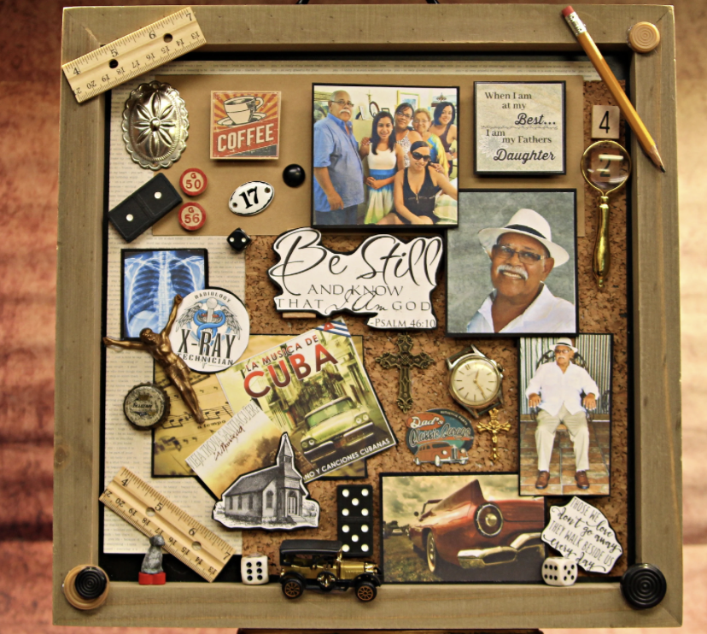

Works Cited
“The History of Upcycling.” Alterist, 2 Jan. 2023, alterist.com/blog/editorial/the-history-of-upcycling.
“The Rise Of Upcycling; A New Era For Fashion.” Alterist, 3 May 2022, alterist.com/blog/editorial/the-rise-of-upcycling.
She, Sophie. “Upcycling Trend: Where Did It Come From?” Sandytimes, 1 July 2024, sandytimes.ae/articles/393/upcycling-trend-where-did-it-come-from.
“Upcycling Defined: A Creative Approach to Sustainable Living.” Plasticreimagined, 6 May 2024, www.plasticreimagined.org/articles/upcycling-expanded-4-ways-it-can-help-the-planet.
Zellinger, Robert. “What Role Does Creativity Play in Upcycling?” Sustainability Directory, 13 Nov. 2025, lifestyle.sustainability-directory.com/question/what-role-does-creativity-play-in-upcycling/.

